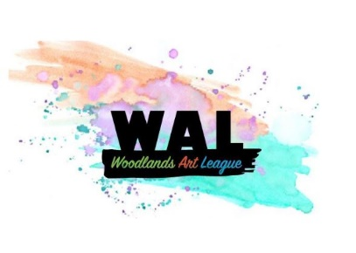
WOODLANDS ART LEAGUE
TEACHING ARTIST AGREEMENT V3

This is an agreement between teaching artists and the Woodlands Art League (WAL), 701 Sawdust Rd., Spring, TX 77380
Woodlands Art League Contact Information:
Contact Person
Phone Number
E=Mail Address

Teaching Artist Information
Name
Phone Number
E-Mail Address
Mailing Address

Program Information
Program Description
Location
Dates
Start/End Times
Minimum number students
Supplies

Cost per student

Woodlands Art League Responsibilities
WAL will:
- Advertise the Program via its website,
- Send email notices to WAL members about the program and include any artist bios or digital images of artists work
- Provide a clean and neat studio space if artists choose to use WAL facilities
- Collect all student fees and maintain an accurate accounting of names of students, fees collected, contact information about the student, etc
- Provide timely reimbursement and accounting for fees collected for Program.

Teaching Artist Responsibilities
The teaching artist will:
- Develop a curriculum and teaching materials for the Program.
- Arrive at least 30 minutes early to set up for Program sessions and will fully clean up after each session ends.
- Procure all supplies as needed for the Program.
- Distribute any permission forms or Program evaluations provided by WAL and will return completed forms to WAL at close of Program.

Fees and Expenses
Teaching Artist will pay WAL 20% of the fee paid by each student enrolled in the class. Students must enroll and pay the fees through the WAL website. Further, the fee is applicable for each student enrolled even if the student pays instructor directly.

Invoice and Reimbursement
The teaching artist will prepare an invoice which specifies the description and dates of the Program and names of each student enrolled. The invoice should indicate the total fees for the workshop and a deduction of a fee of 20% calculated for each student attending. The teaching artist will submit the invoice by email or mail to WAL contact person above. Sample invoice attached.

WAL will process and pay invoices no later than two weeks after receipt of such invoice. The IRS requires that payments made to non-employee contractors be given a Form 1099 Misc for any payments made to the contractor in excess of $600 in a calendar year. As such please complete and return the attached Form W-9 with this agreement. A copy of the W-9 must be received by WAL prior to payment being made to you.

This Teaching Artist Agreement consists of this form and the attached terms and conditions, if any. By signing below, Teaching Artist understands the terms of this Agreement including those relating to payment and responsibilities.

Teaching Artist Woodlands Art League

_________________________________ ____________________________________
Signature Signature

_________________________________ ____________________________________
Print Name Print Name

_________________________________ ____________________________________
Print Title (if applicable) Print Title

________________________________ ____________________________________
Date Date

Teaching Artist Name
Mailing Address
Mailing Address
Phone, Email

Date:

To Woodlands Art League
Re: Payment for Workshop

Workshop Description:
Workshop Date:
Cost Per Student:

Names of Students (list)
__________________________________
__________________________________
__________________________________
__________________________________
__________________________________
__________________________________
__________________________________

Total Fees for Workshop $________xxxxxx_____
20% Commission to WAL ________(xxxxx)_____
Other Expenses for Reimbursement ____________________
(attach receipts)
Total Amount Due Instructor $____________________

